1. Project Overview
This project analyzes sales data to understand sales performance across different segments, countries, products, years, and months. Python was used for data cleaning and analysis, Excel was used for pivot tables and charts, and Power BI was used to create an interactive sales dashboard.
2. Findings
- Government segment has the highest sales.
- Paseo is the highest-selling product.
- Mexico has the lowest sales among the countries.
- 2014 has much higher sales than 2013.
- October has the highest monthly sales.
3. Recommendations
- Focus more on the Government segment.
- Continue promoting Paseo.
- Improve sales strategies in Mexico.
- Study the reasons for the strong performance in 2014.
- Plan marketing campaigns around high-performing months.
4. Tools & Technologies Used
- Python – Used for data cleaning, analysis, visualization, and regression modeling.
- Pandas – Used for handling and cleaning the dataset.
- Matplotlib – Used to create graphs and charts.
- Scikit-learn – Used for the linear regression model.
- Microsoft Excel – Used for PivotTables and sales analysis.
- Power BI – Used to create the sales dashboard.
5. Conclusion
The sales analysis provided useful insights into the company's sales performance. The analysis showed differences in sales across segments, countries, products, years, and months. Python, Excel, and Power BI helped clean, analyze, visualize, and understand the data. The findings and recommendations can help identify strong-performing areas and improve sales performance.
6. Project Evidence / Screenshots
Figure 1-8: Python data cleaning and analysis
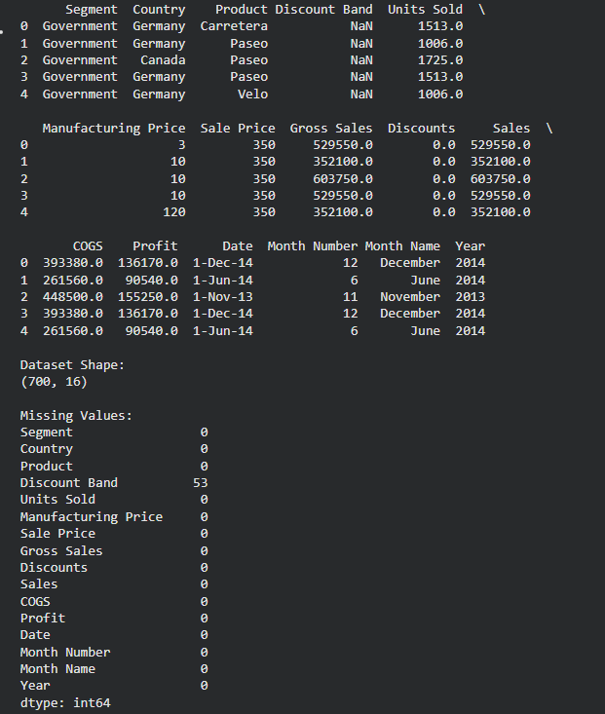
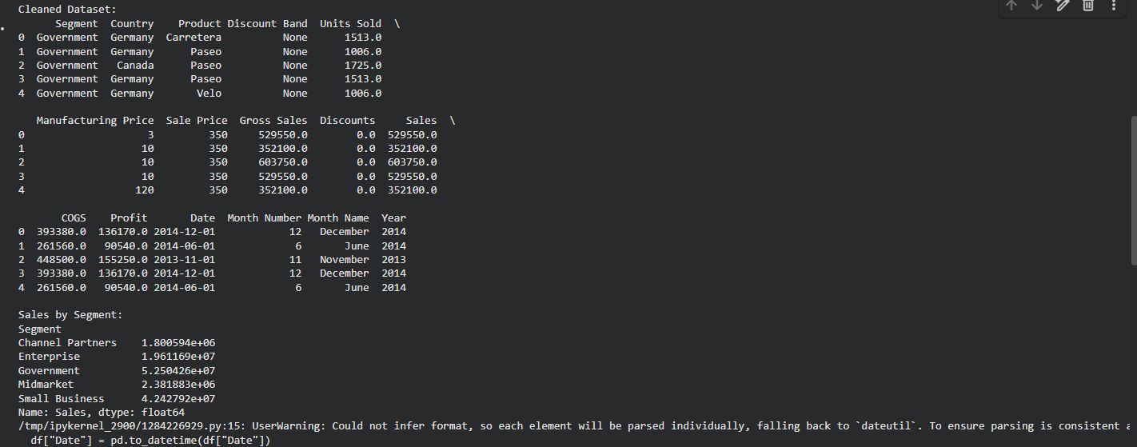
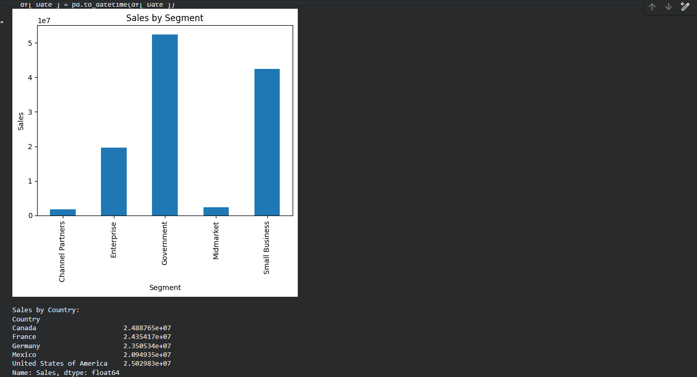
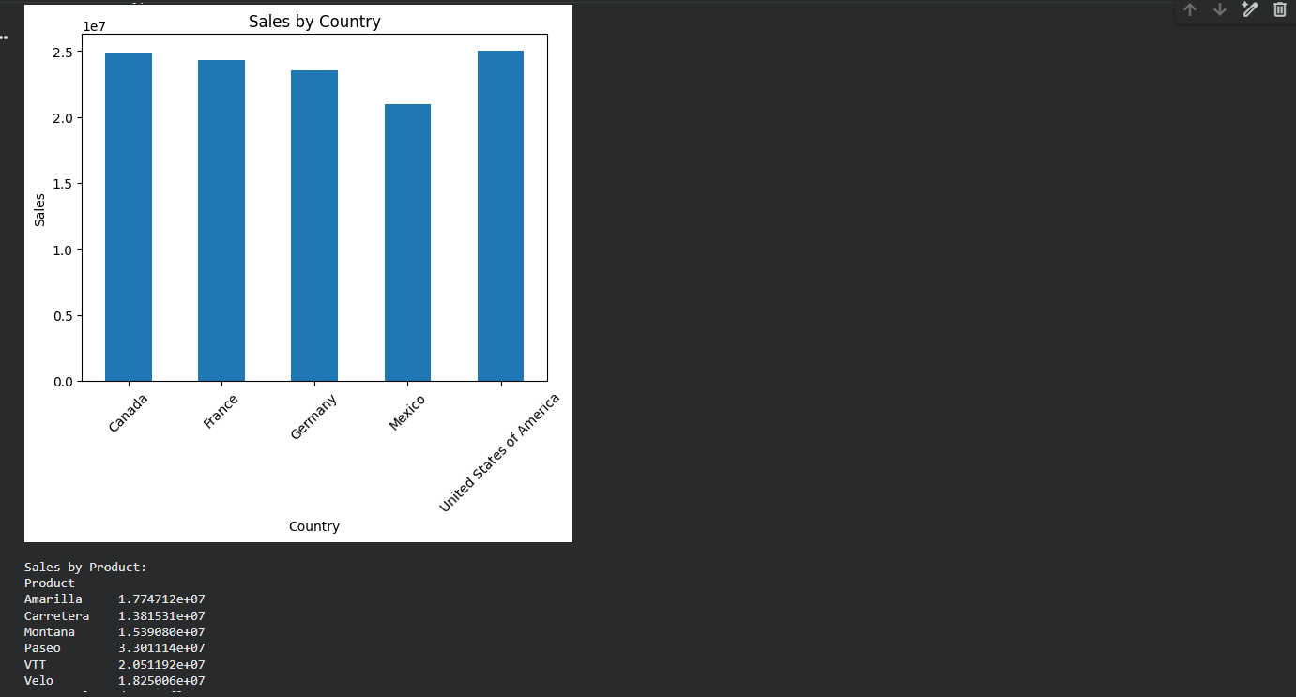
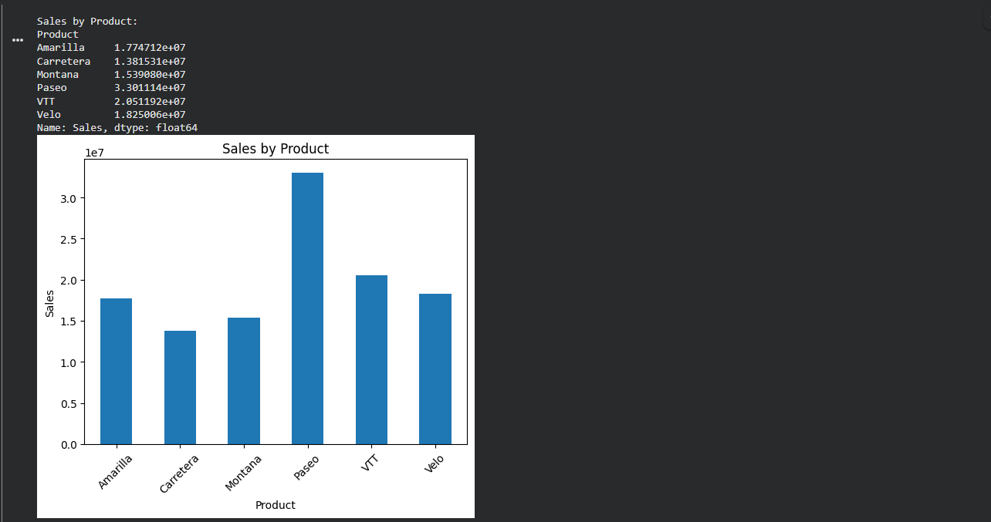
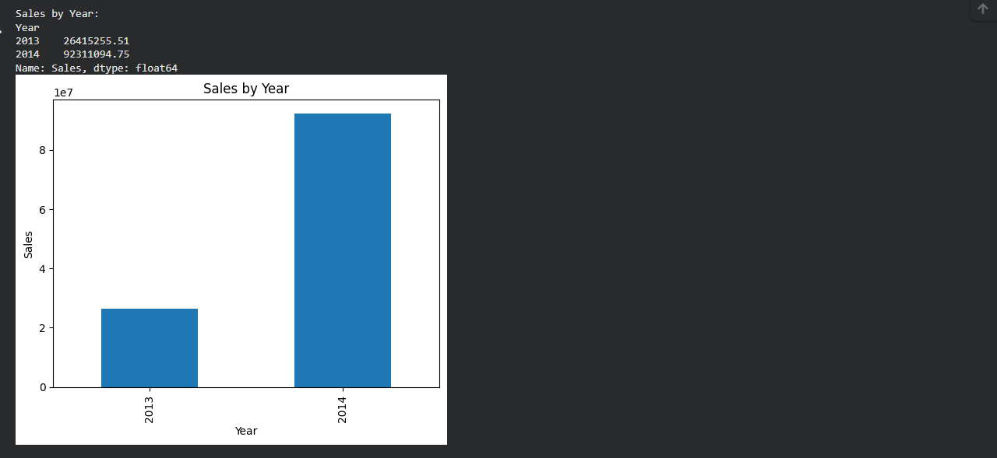
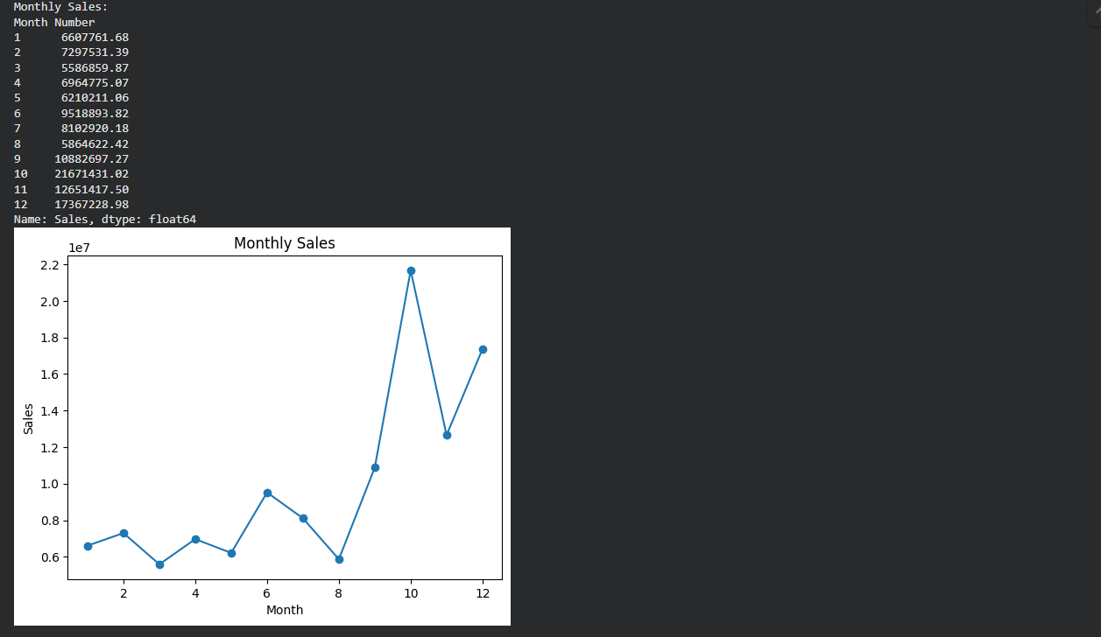
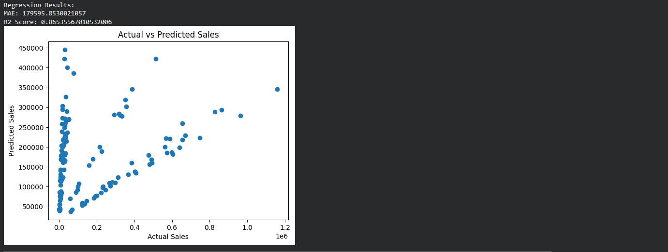
Figure 9: Excel Sales by Segment
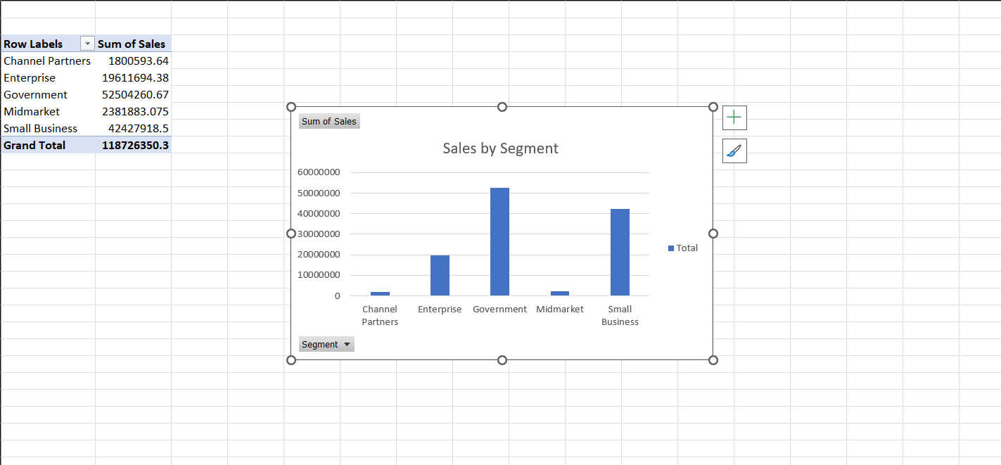
Figure 10: Excel Sales by Country
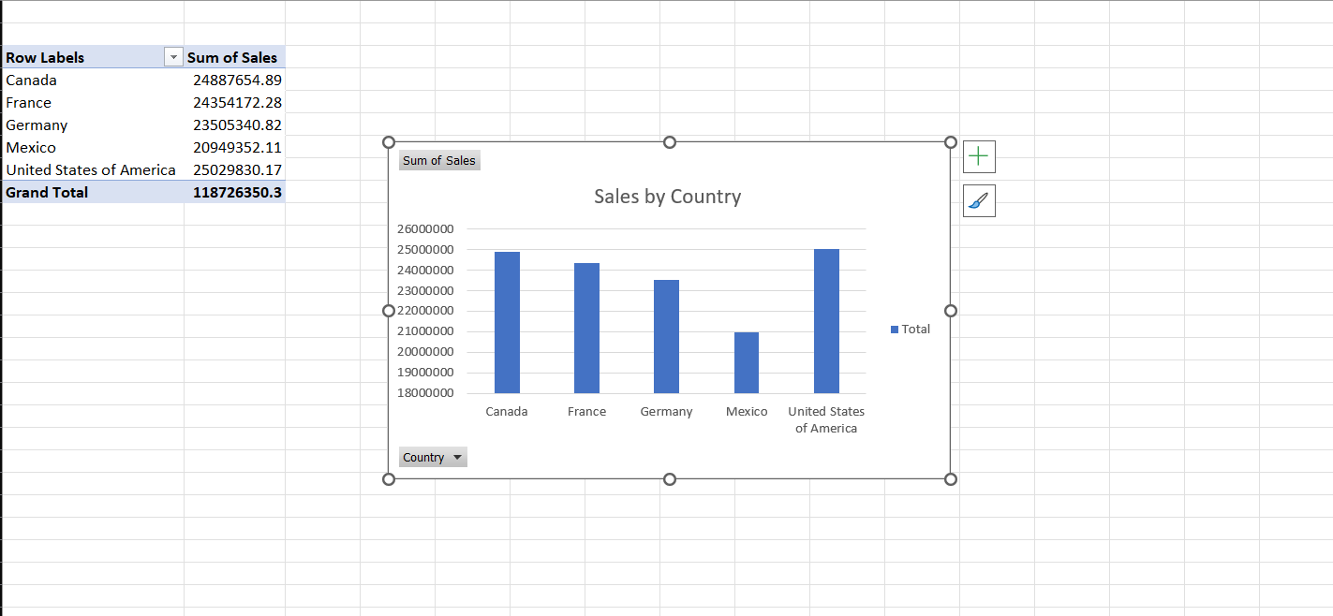
Figure 11: Excel sales by Product
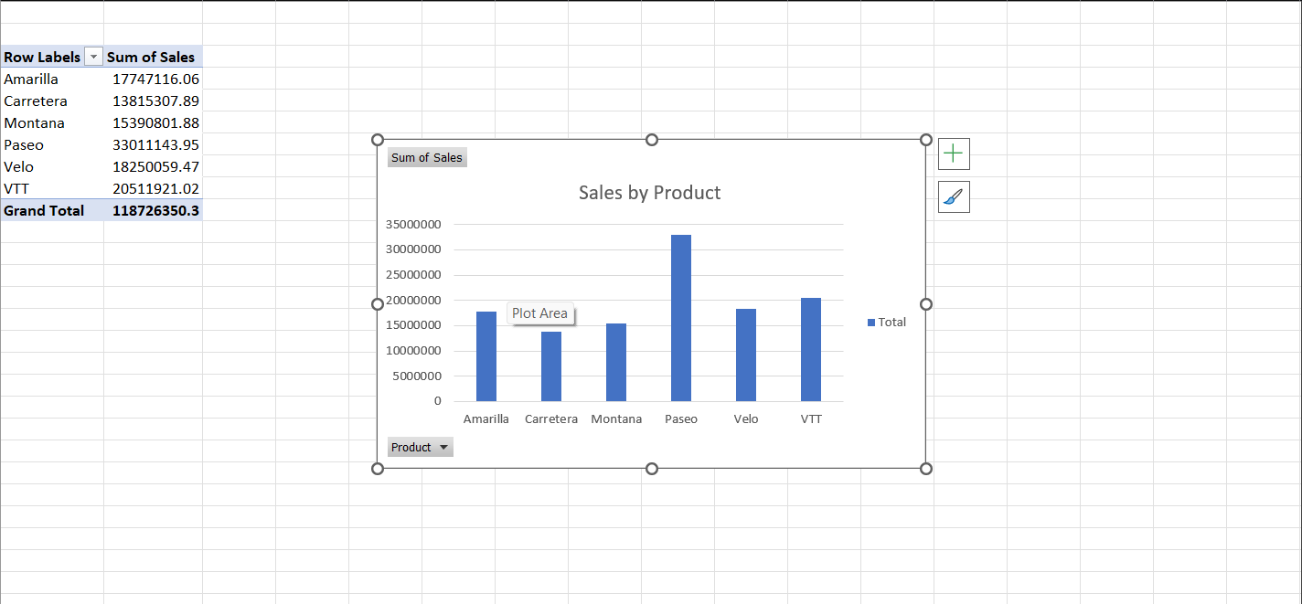
Figure 12: Excel sales by year
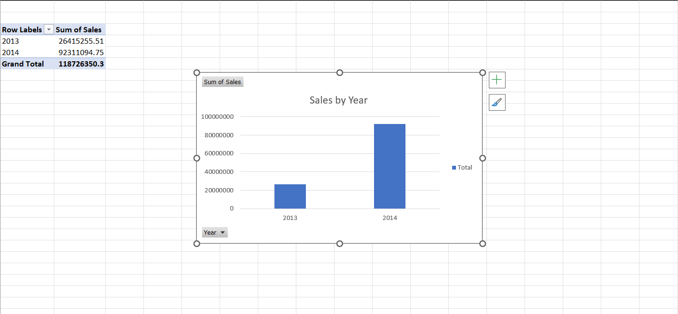
Figure 13: Monthly Sales
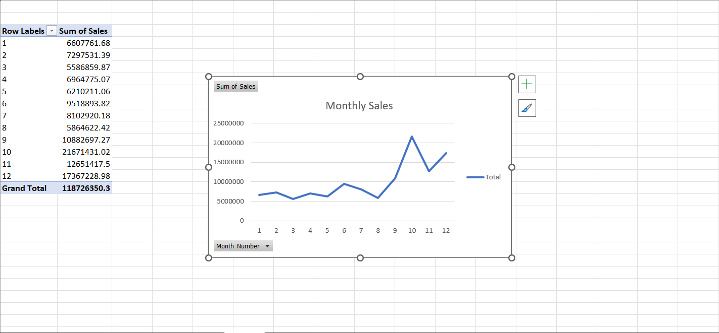
Figure 14: Final Power BI Sales Dashboard
